**Question 1**

1. Construct and Unity. The game engine Unity is selected because it is able to handle and create more complex programs unlike construct which slows down much faster than Unity.
2. C# & Java.

C# -

* Object Oriented.
* It is very modern and simple.
* The compiler shows you errors before executing the program.
* Gives you suggestions on what is missing or wrong.

**Question 2**

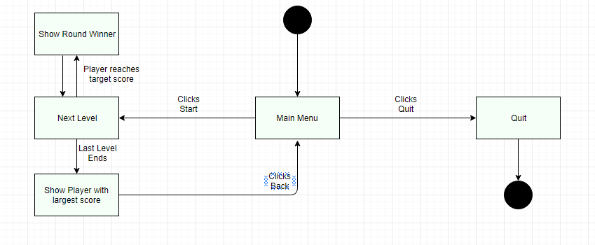

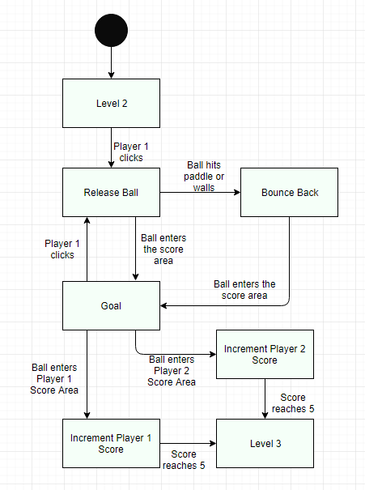

**Question 3**

When a file is compressed it would make the file smaller because it would either delete redundant date or find clever ways to store it. It would help make transfer speeds faster due to its decreased size and because of this, it would increase speed at which servers save and share data because it would take less time to read and write data. Because of this it also helps save energy since compression saves up time. This also means that renting servers is cheaper because less powerful equipment is needed to keep high speeds and the power they would save.